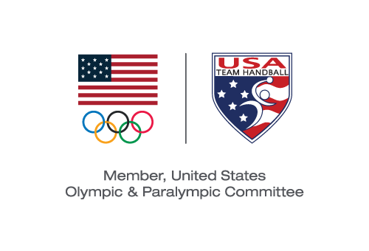
USA TEam Handball BOARD MEETING
Action Taken Without a Meeting Effective November 14, 2019

Pursuant to Section 6.24 of the USA Team Handball (“USATH”) Bylaws, the Board of Directors (the “Board”) took the following actions by email voting with the same effect as action taken at a meeting of the Board:

VOTED: To approve the adoption of the USATH Financial Policies and Procedure presented to the Board.

VOTED: To approve an amendment to the USATH Bylaws by which Section 14.10 thereof is deleted in its entirety and replaced with the following new Section 14.10:

“Section 14.10. Processing A Complaint.

Where a complaint is filed involving selection of an individual to participate in a competition, the complainant shall include with the complaint a list of all other individuals, together with their contact information (if known), that the complainant believes may be adversely affected by a decision rendered on the complaint. The adverse party to the complaint shall also submit a list of individuals, together with their contact information (if known), that may be adversely affected by a decision rendered on the complaint. The Hearing Panel may also determine that individuals not listed by either the complainant or respondent shall be given notice. The Hearing Panel shall then promptly determine which individuals must be given notice of the complaint. The Hearing Panel shall also approve the notice to be given. Unless determined otherwise by the Hearing Panel, the Hearing Panel shall then be responsible for providing appropriate notice to these individuals. Any individual so notified of the complaint shall have the option to participate in the proceeding as a party. If an individual is notified of the complaint, then that individual shall be bound by the decision of the Hearing Panel, regardless of whether the individual chooses to participate or not.

In all hearings conducted by USA Team Handball under these Bylaws, the parties shall be accorded:

1) notice of the specific charges, claims, or alleged violations in writing and possible consequences if the charges, claims, or alleged violations are found to be true;
2) reasonable time between receipt of the notice of charges and the hearing process.”

Michael J. Wall
Chair and President

